Databricks setup
This activity focuses on creating and configuring an Azure Databricks workspace through the Azure Portal.It also verifies the setup by creating a notebook and running basic Spark code successfully.

Step 1: Azure Portal Home
- Login to Microsoft Azure Portal
- Navigate to Azure Services
- Click on Azure Databricks

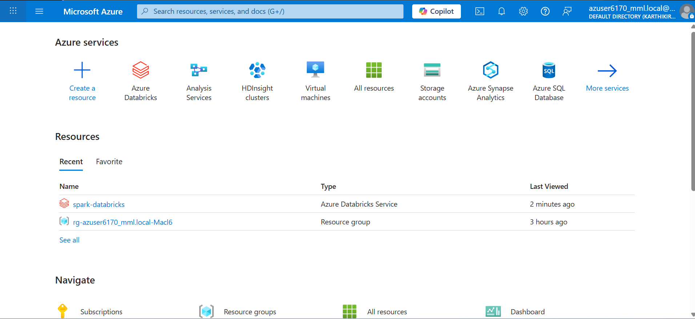
Step 2: Databricks Resource List
- View existing Databricks resources
- Click on your workspace (e.g., spark-databricks)
- Verify Resource Group and Subscription

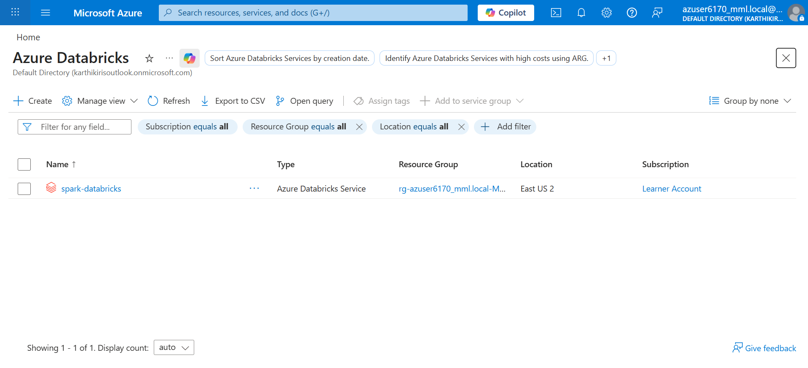
Step 3: Create Databricks Workspace – Basics
- Click Create Resource → Azure Databricks
- Fill the following:
  - Subscription: Learner Account
  - Resource Group: Select existing / Create new
  - Workspace Name: Enter name

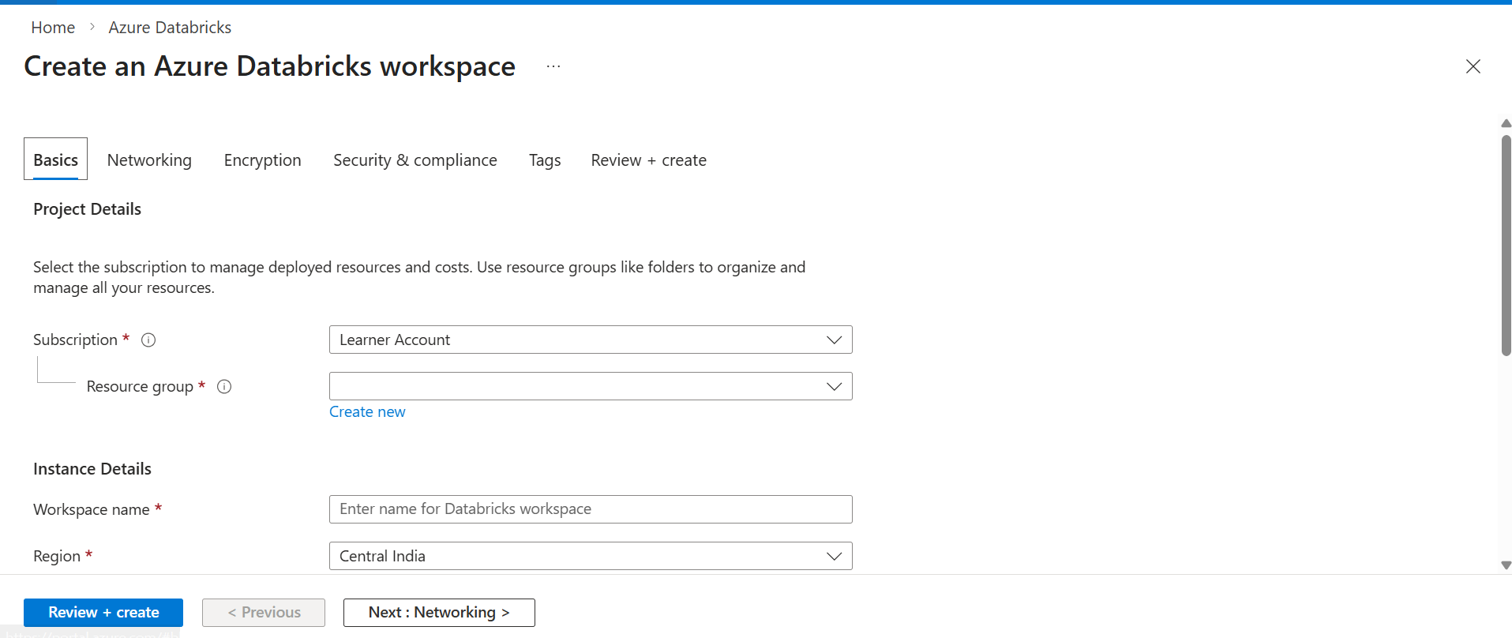

Step 4: Fill Workspace Details
- Provide required details:
  - Workspace Name: spark-cluster
  - Region: Central US
  - Pricing Tier: Standard
  - Workspace Type: Hybrid

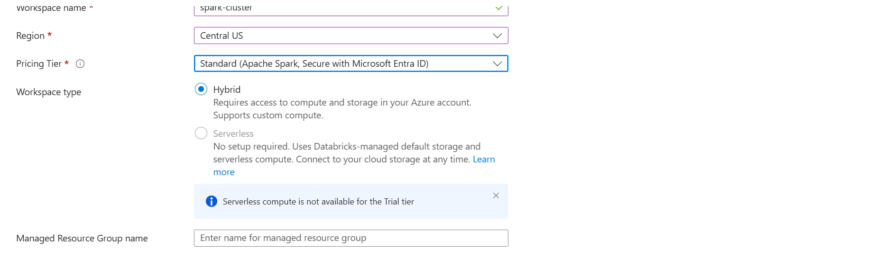
Step 5: Networking Configuration
- Configure networking settings:
  - Secure Cluster Connectivity: Yes
  - Virtual Network: No (default)
- Click Next

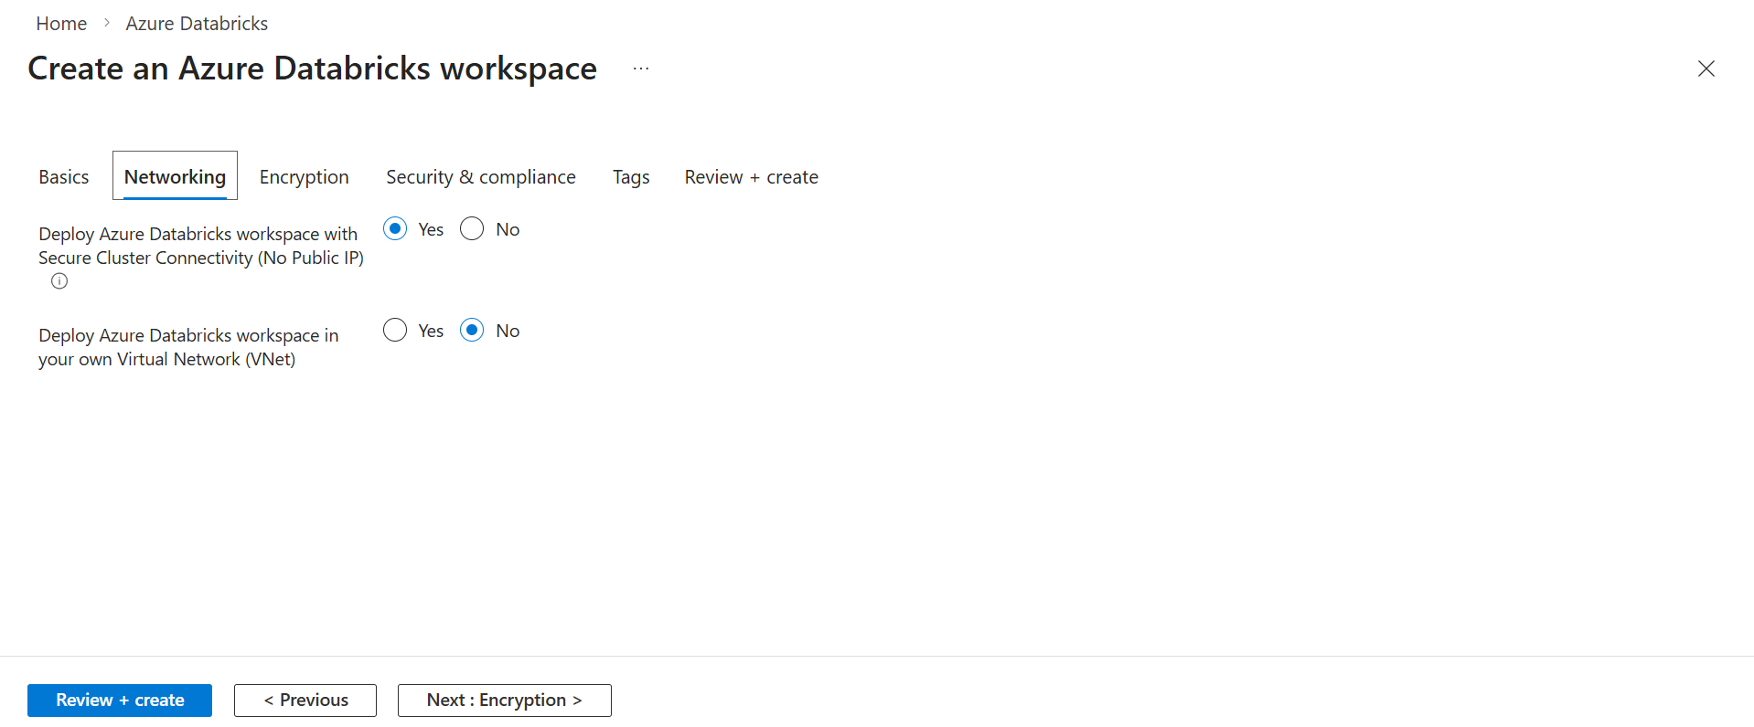

Step 6: Review and Create
- Review all configurations
- Validate settings
- Click Create

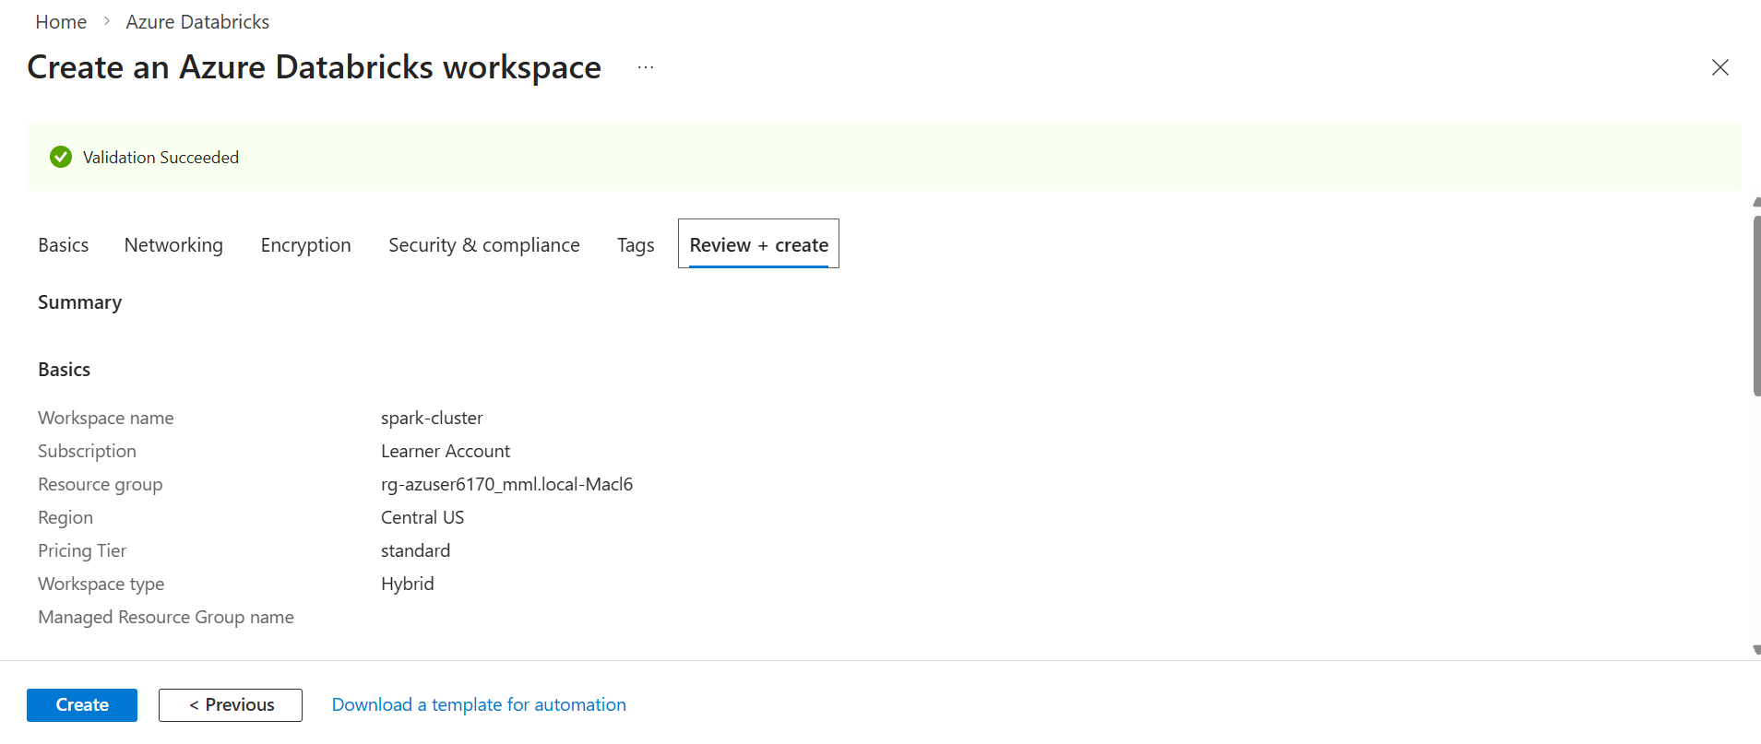
Step 7: Deployment in Progress
- Azure starts deployment
- Status shows: Deployment is in progress
- Wait for completion

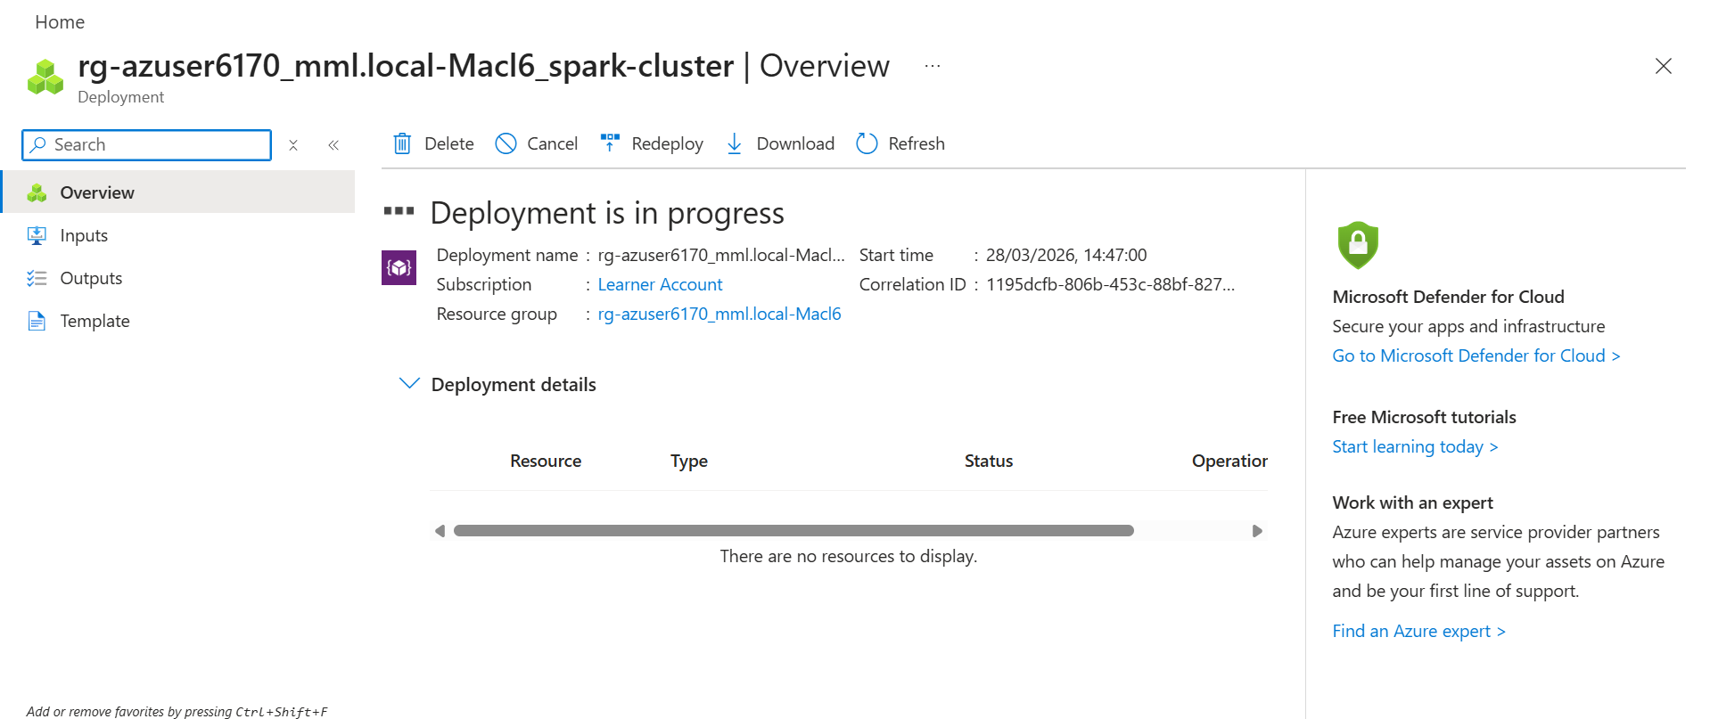

Step 8: Deployment Completed
- Deployment successful
- Click Go to Resource

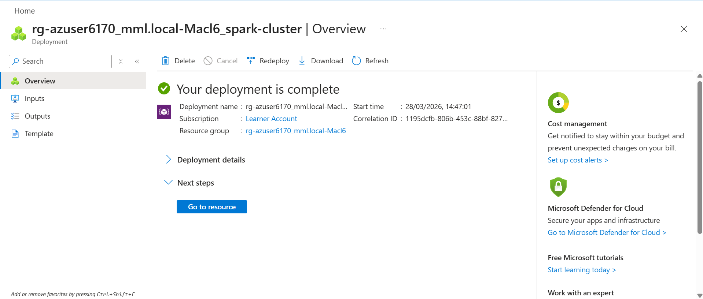
Step 9: Databricks Workspace Home
- Databricks workspace is launched
- You can see:
  - Workspace menu
  - Compute
  - Catalog
  - Jobs

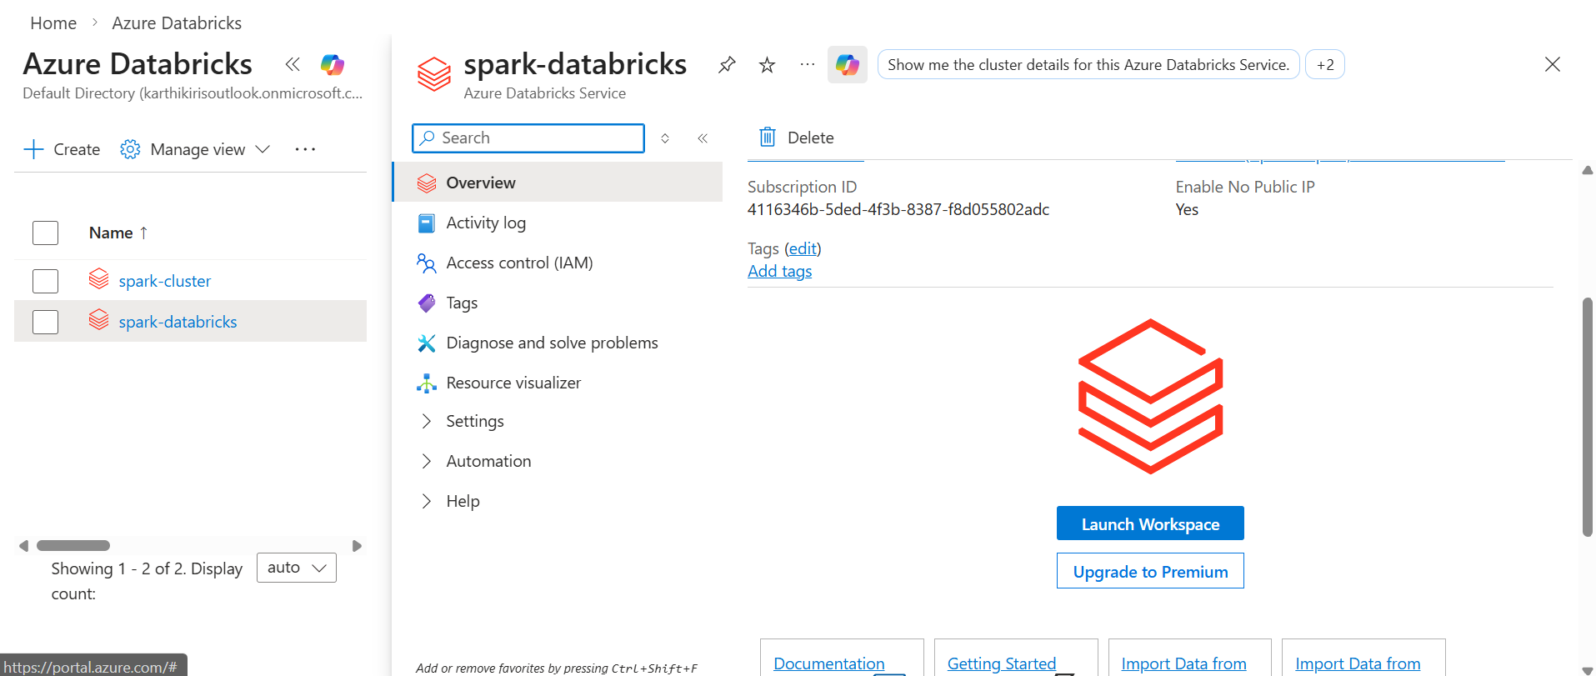

Step 10: Create Notebook in Databricks
After opening Databricks workspace, click on New
- From dropdown, select Notebook
- This option is used to create a new notebook where we write PySpark code

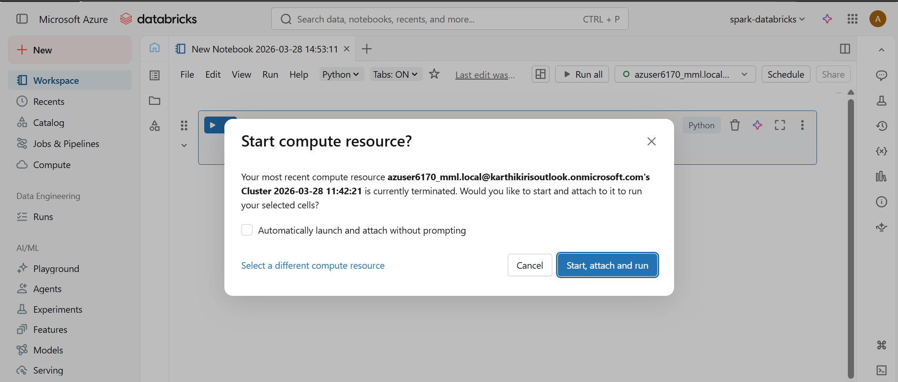
Step 11: Run Spark Code
- After cluster starts, notebook is connected
- Run the code:
spark.version
- Output displays Spark version (e.g., 4.0.0)
- This confirms Spark cluster is working successfully

